23CSE101

OBJECT ORIENTED PROBLEM SOLVING

LAB MANUAL



**Department of computer and communication Engineering Amrita School of Engineering**

**Amrita Vishwa Vidyapeetham, Amaravati Campus**

# Name: Astha Kiran

**Verified By: Roll No: AV.SC.U4CSE24010**

**Date of submission: Sem: 1st Year**

**Class: CSE/A**

|  |  |  |  |  |
| --- | --- | --- | --- | --- |
| SNo | Title | Date | Page No | Signature |
| WEEK 1 |  |  |  |  |
| 1 | How to download and install JAVA |  |  |  |
| 2 | Write a java program to print the message ‘Welcome to Java Programing’ |  |  |  |
| 3 | Write a Java Program to print name Roll and Section of the student |  |  |  |
| WEEK 2 |  |  |  |  |
| 1 | Write a java program to calculate area of rectangle |  |  |  |
| 2 | Write a java program to convert celsius into fahrenhiet to celsious and vice versa |  |  |  |
| 3 | Write a java program to calculate the simple interest |  |  |  |
| 4 | Write a java program to find the largest of the number using ternatary operatop |  |  |  |
| 5 | Write a java program to find the factorial of the number |  |  |  |
| WEEK 3 |  |  |  |  |
| 1 | Create a java program with the following instructions:   1. Create a class with name Car. 2. Create attributes named Car_color, Car_Brand,Fuel_type,mileage. 3. Create three methods named start(), stop(), service(). 4. Create three objects car1, car2, car3. 5. Create one constructor which should print “welcome to my garage”. |  |  |  |
| 2. | Write a JAVA Program to create a class named bank account with two methods deposit() and withdraw():   1. In deposit()- whenever an amount is deposited, it has to be updated with the current amount. 2. Withdraw()- whenever an amount is being withdrawn it has to be less than the current balance otherwise print insufficient balance. |  |  |  |

# 

|  |  |  |  |  |
| --- | --- | --- | --- | --- |
| SNo | Title | Date | Page No | Signature |
| WEEK 4 |  |  |  |  |
| 1 | Write a JAVA Program with class named Book:   1. The class should contain various attributes such as “title_of_book, Author, year_of_publication”. 2. It should also contain a constructor with parameters which initializes “title_of_book, Author, year_of_publication”. 3. Create a method which displays the details of the book “title_of_book, Author, year_of_publication”. 4. Display the details of the two books by creating two objects. |  |  |  |
| 2 | To create a JAVA program with class named Myclass:   1. with “static variable-count” of int type, initialize to zero and a constant variable “pi-double” to initialize to 3.1415 as attributes of that class. 2. Now define a constructor for Myclass that increments the count variable each time object for Myclass is created. Finally print values of “count” and “pi” variables. |  |  |  |
|  | Write a java program to print the message ‘Welcome to Java Programing’ |  |  |  |
|  | Write a Java Program to print name Roll and Section of the student |  |  |  |

# WEEK-1

# Program1)

# AIM – To download and install JAVA

# PROCEDURE

# 1)Search “Java download” in the search bar (e.g. Google)

# 2) Go to the website of Oracle

# 

# 3)Download the LTS(Long-Term Support) version of jdk.

# Here it is “jdk21”

4) Select your operating System i.e. for me it is windows so I m selecting

windows option. Then select x64 installer

# 

5) Download and installation.

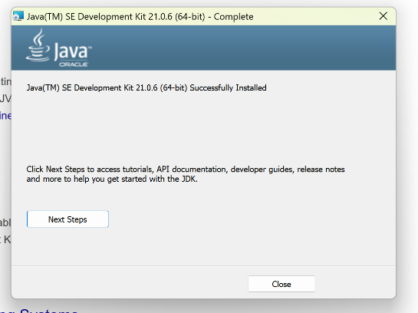

**6**) C Drive 🡪 Program files 🡪 Java 🡪 jdk21 🡪 libraries + modules 🡪bin

Now select and copy the path**.**

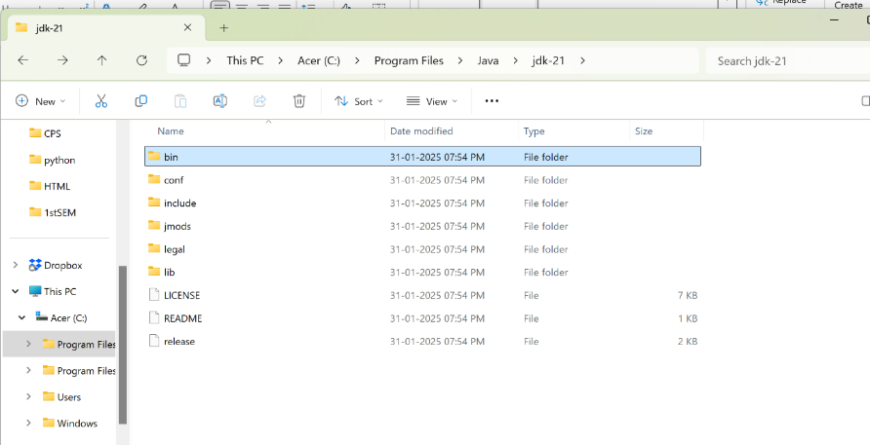

7) Press Windows + R, type sysdm.cpl, and click Ok.

8) The System Properties window will open.

9) Navigate to the Advanced tab.

10) Click on Environment Variables at the bottom.

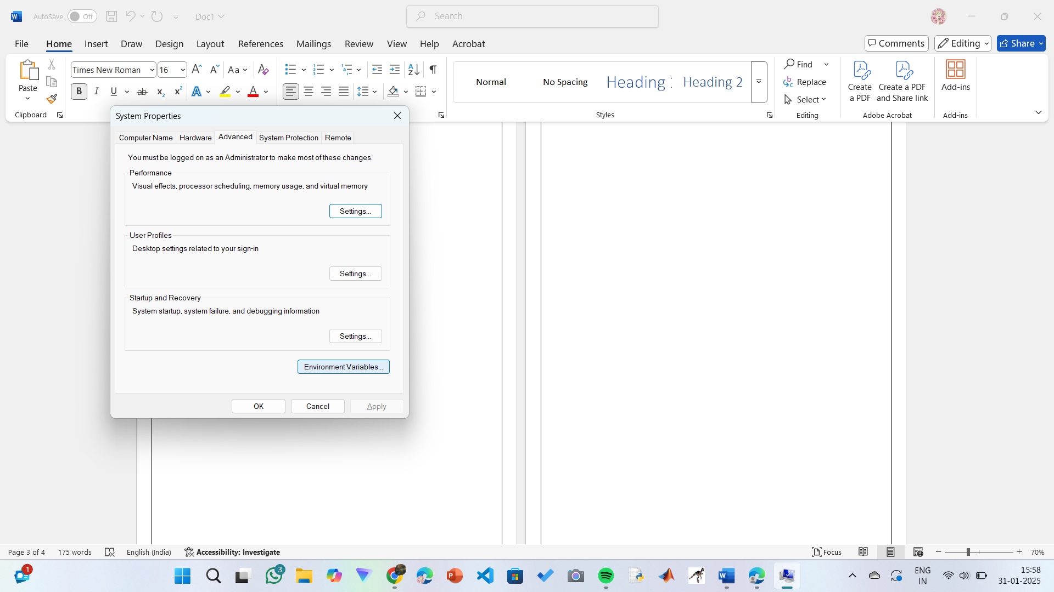

11) Under System Variables, click New.

12)Set the Variable name as Java_home.

13) Set Variable value as C:\Program Files\Java\jdk-21

(or your installation path).

Click OK.

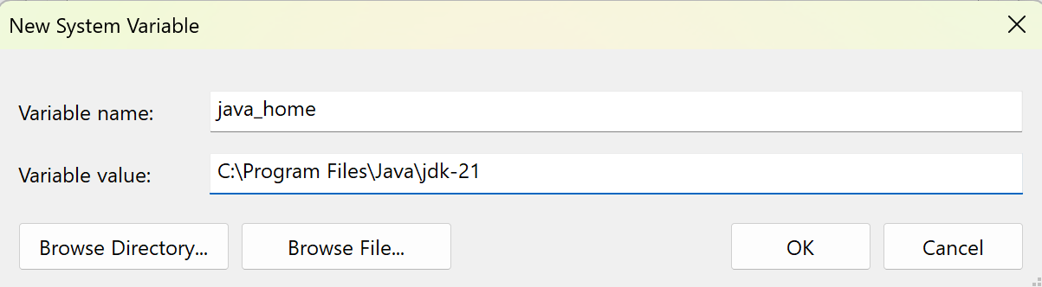

14) In System Variables, find Path and double click on it.

15)Click New and add: C:\Program Files\Java\jdk-21\bin

16)Click OK to save.

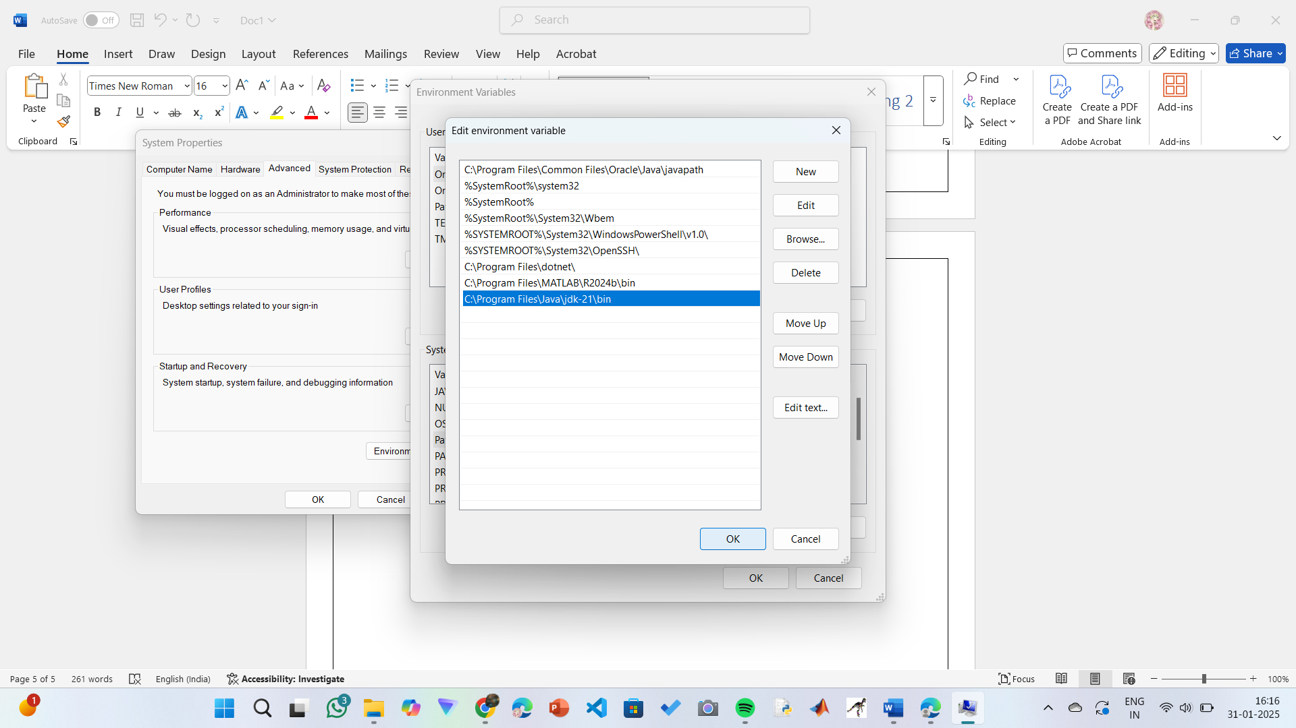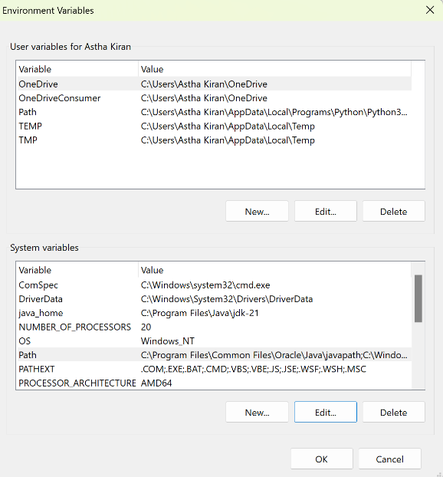

**Step 17:Verify Installation**

1. Open Command Prompt.
2. Type the following command: **java --version** and press Enter.

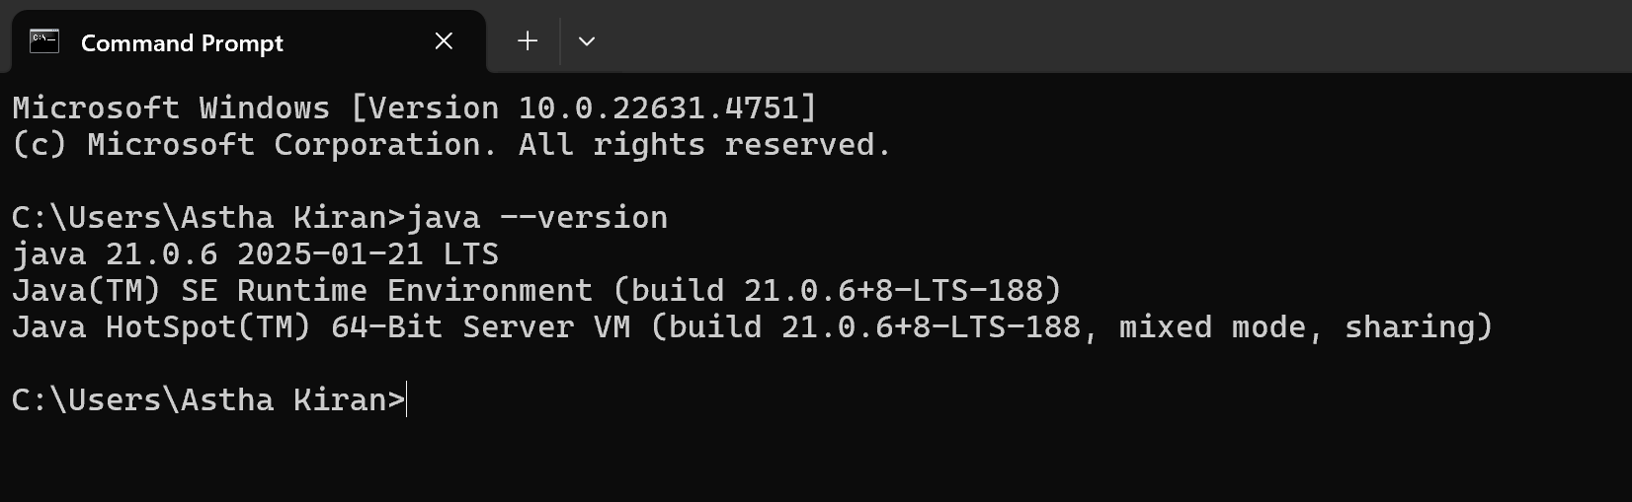

**Program 2)**

# AIM – To print the statement “Welcome to Java” using JAVA

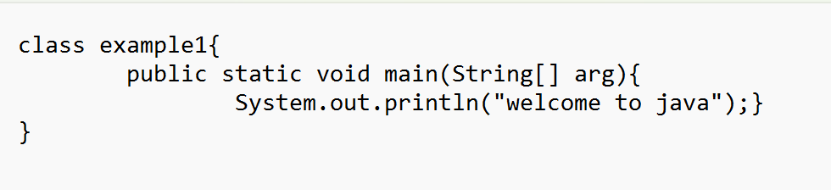

# 

**Output**

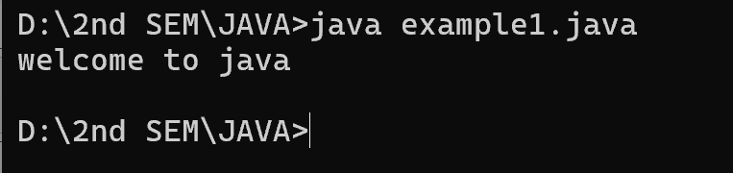

|  |  |  |
| --- | --- | --- |
| **S.No.** | **Errors** | **Rectification** |
| 1. | error: ';' expected System.out.println("welcome to java")} | Adding ‘;’ at the end of the statement  System.out.println("welcome to java"); |
| 2. | error: cannot find symbol  public static void main(string[] arg){ | **String** symbol instead of string |

**Concepts to be known:**

* System.out.println(" ")-to print the statement

**Program 3)**

**AIM-To print Name Roll and Section of the student using JAVA**

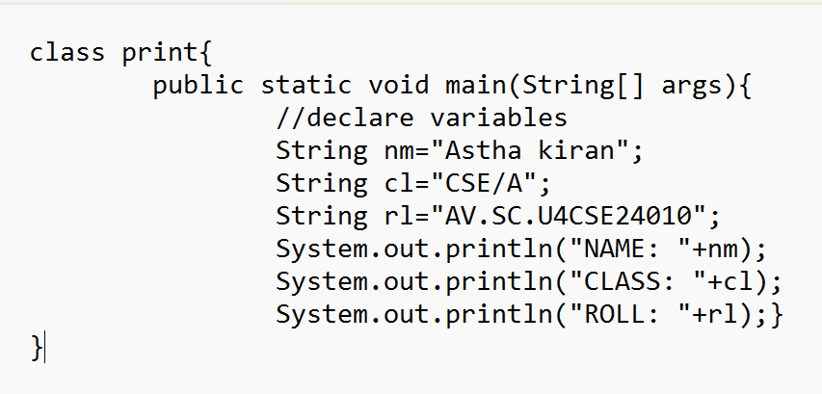

**Output**

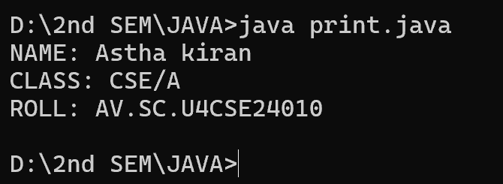

|  |  |  |
| --- | --- | --- |
| **S.No.** | **Errors** | **Rectification** |
| 1. | error: cannot find symbol  string cl="CSE/A"; | **String** symbol instead of string |

**Concepts to be known:**

* System.out.println(" ")-to print the statement
* String – to declare the data type as string
* // - used to write comments

**WEEK-2**

**Program 1)**

**AIM- to calculate area of rectangle using JAVA**

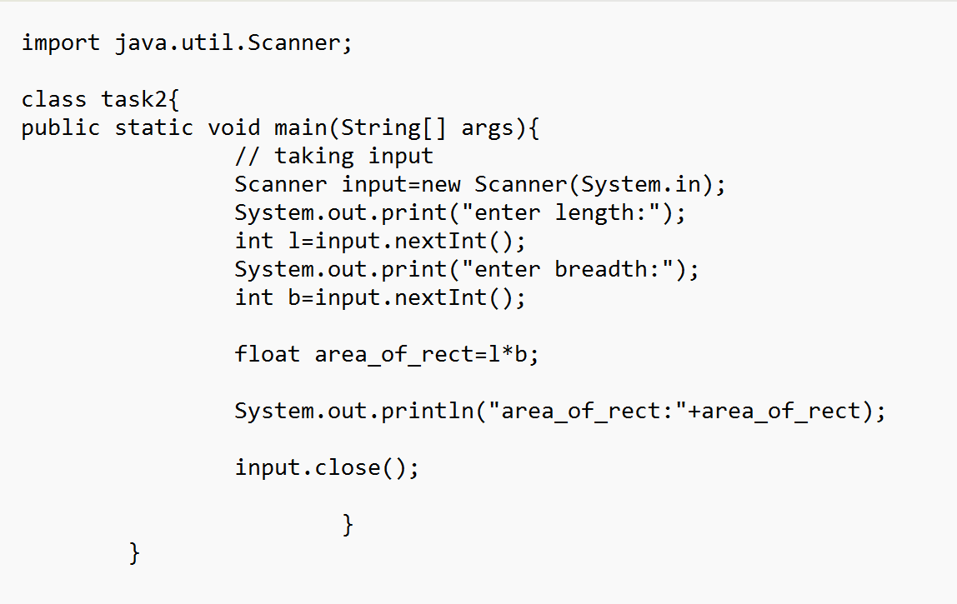

**Output**

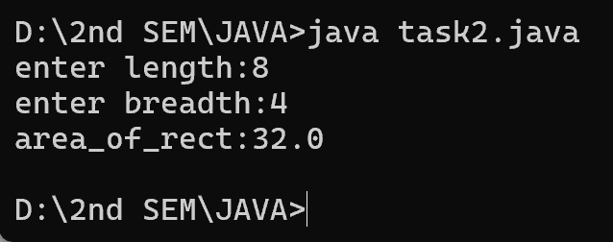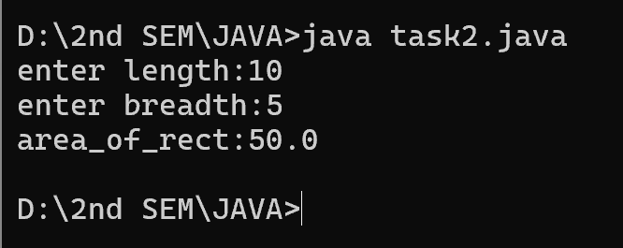

|  |  |  |
| --- | --- | --- |
| **S.No.** | **Errors** | **Rectification** |
| 1. | error: cannot find symbol  int b=input.nextint(); | Replace nextint() with nextInt() |

**Concepts to be known:**

* **Import**- to import the
* System.out.println(" ")-to print the statement
* String – to declare the data type as string
* float – to declare the data types as float
* int – to declare the data types as integer
* // - used to write comments
* Scanner input=new Scanner(System.in):
* int <variable name>=input.nextInt():

**Program 2)**

**AIM- To convert Celsius to fahrenheit and vice versa**

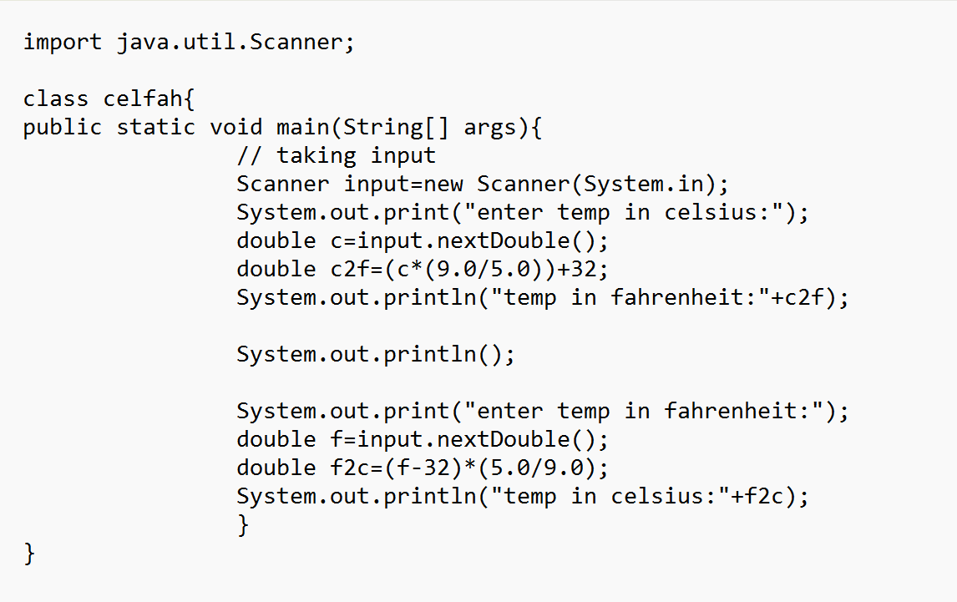

**Output**

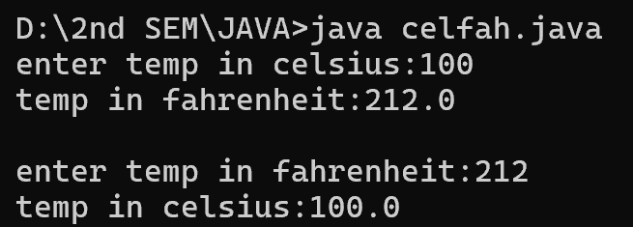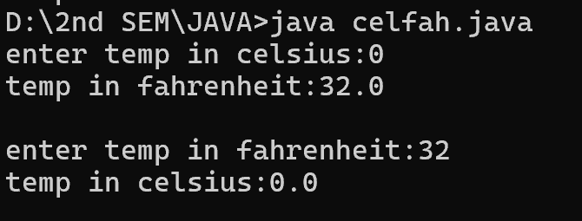

|  |  |  |
| --- | --- | --- |
| **S.No.** | **Errors** | **Rectification** |
| 1. | error: incompatible types: possible lossy conversion from double to float  float c2f=(c*(9.0/5.0))+32; | Replace float with double |
| 2. | error: incompatible types: possible lossy conversion from double to float  float f2c=(f-32)*(5.0/9.0); | Replace float with double |

**Concepts to be known:**

* + **Import** -to import scanner class
  + System.out.println(" ")-to print the statement
  + String – to declare the data type as string
  + float – to declare the data types as float
  + int – to declare the data types as integer
  + // - used to write comments
  + Scanner input=new Scanner(System.in):
  + int <variable name>=input.nextInt():

**Program 3)**

**AIM- to calculate the simple interest using JAVA**

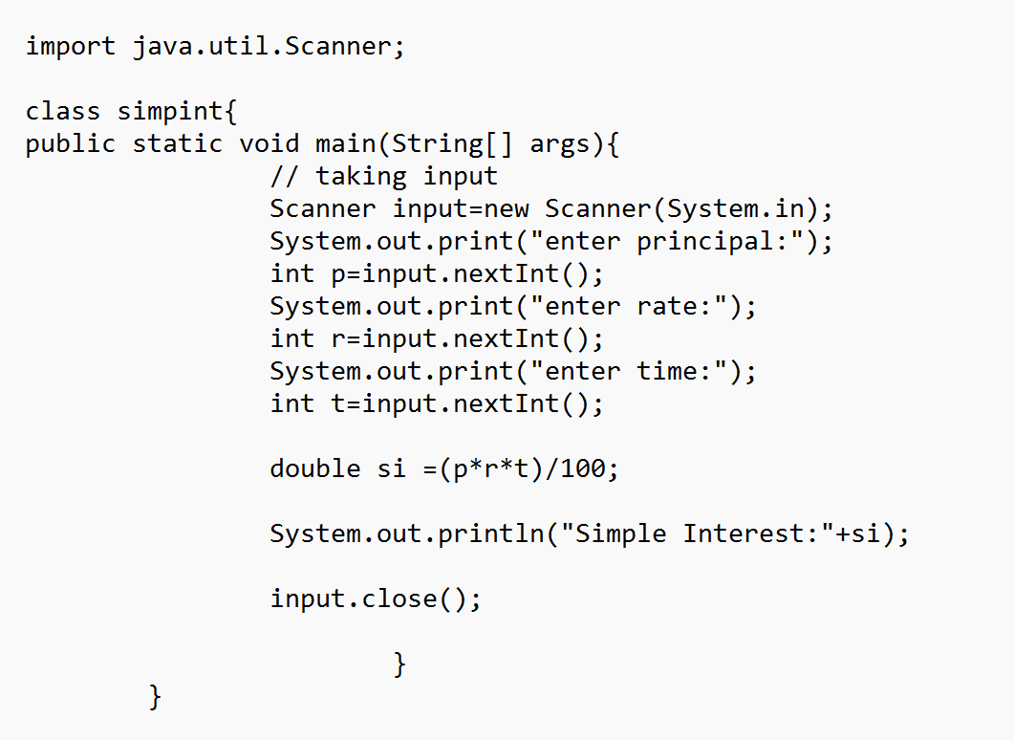

**Output**

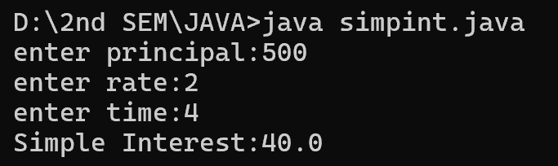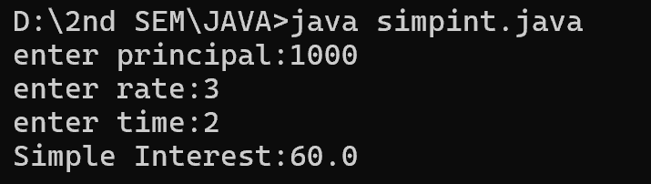

|  |  |  |
| --- | --- | --- |
| **S.No.** | **Errors** | **Rectification** |
| 1. | error: <identifier> expected  public Static void main(String[] args) | Replace Static with static |
| 2. | error: cannot find symbol  int r=input.nextint(); | Replace nextint() with nextInt() |

**Concepts to be known:**

* + **Import** -to import scanner class
  + System.out.println(" ")-to print the statement
  + String – to declare the data type as string
  + double – to declare the data types as double
  + int – to declare the data types as integer
  + // - used to write comments
  + Scanner input=new Scanner(System.in):
  + int <variable name>=input.nextInt():

**Program 4)**

**AIM- To find the largest of the number using ternatary operator**

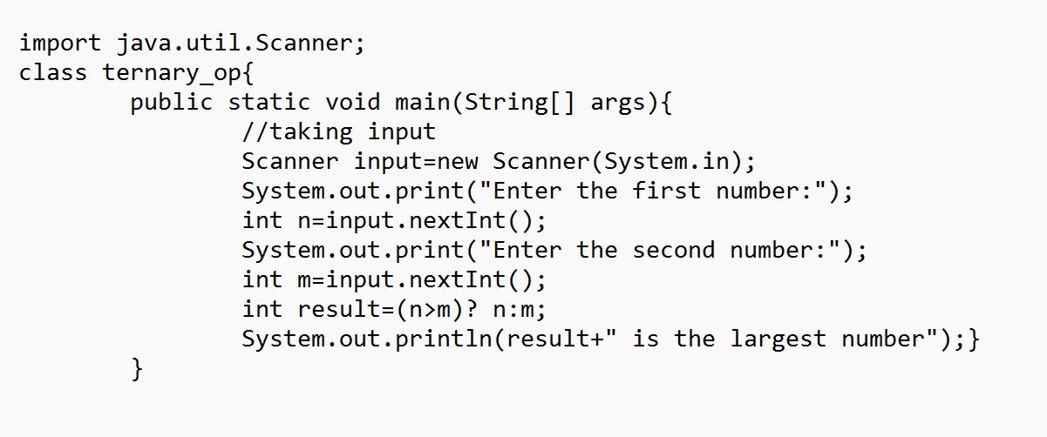

**Output**

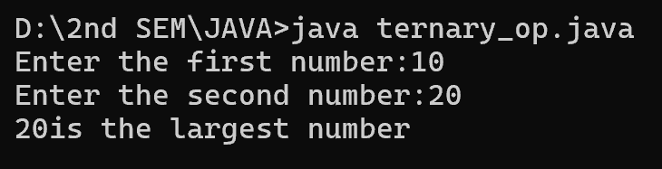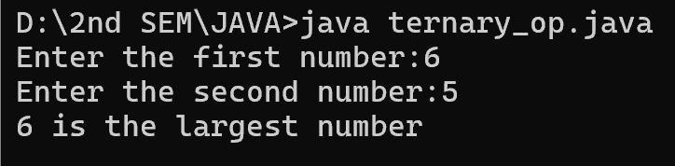

|  |  |  |
| --- | --- | --- |
| **S.No.** | **Errors** | **Rectification** |
| 1. | error: cannot find symbol  string result=(n>m)? n:m; | Change the data type of result to int |

**Concepts to be known:**

* + **Import** -to import scanner class
  + System.out.println(" ")-to print the statement
  + String – to declare the data type as string
  + int – to declare the data types as integer
  + // - used to write comments
  + Scanner input=new Scanner(System.in):
  + int <variable name>=input.nextInt():

**Program 5)**

**AIM- To find the factorial of the number using JAVA**

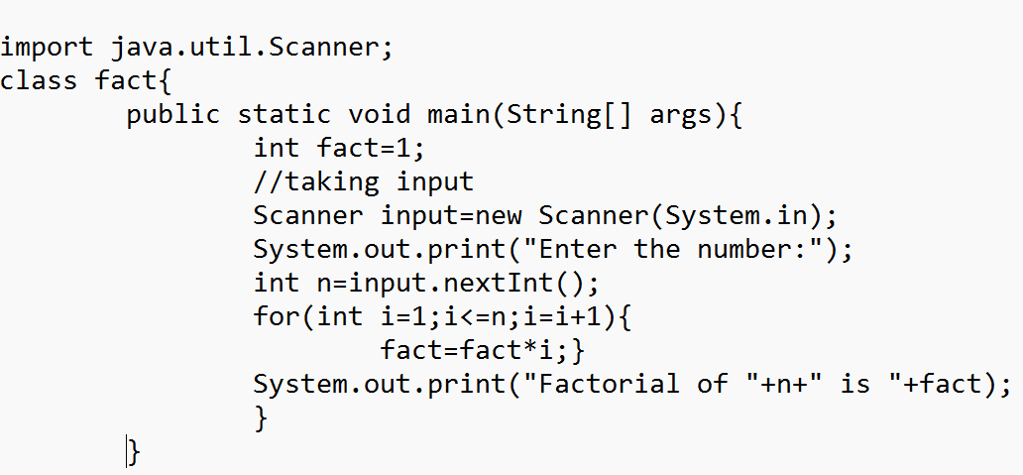

**Output**

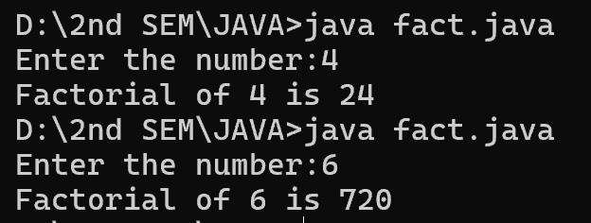



|  |  |  |
| --- | --- | --- |
| **S.No.** | **Errors** | **Rectification** |
| 1. | error: not a statement  for(int i=1;i<=n;i+i+1) | i=i+1 |
| 2. | error: ';' expected  fact=fact*i | Adding ; at the end |

**Concepts to be known:**

* + **Import** -to import scanner class
  + System.out.println(" ")-to print the statement
  + String – to declare the data type as string
  + int – to declare the data types as integer
  + // - used to write comments
  + Scanner input=new Scanner(System.in):
  + int <variable name>=input.nextInt():

**WEEK-3**

**Program1)**

**AIM-** To create a java program with the following instructions:

1. a class with name Car.
2. attributes named Car_color, Car_Brand,Fuel_type,mileage.
3. three methods named start(), stop(), service().
4. three objects car1, car2, car3.
5. one constructor which should print “welcome to CAR garage”.

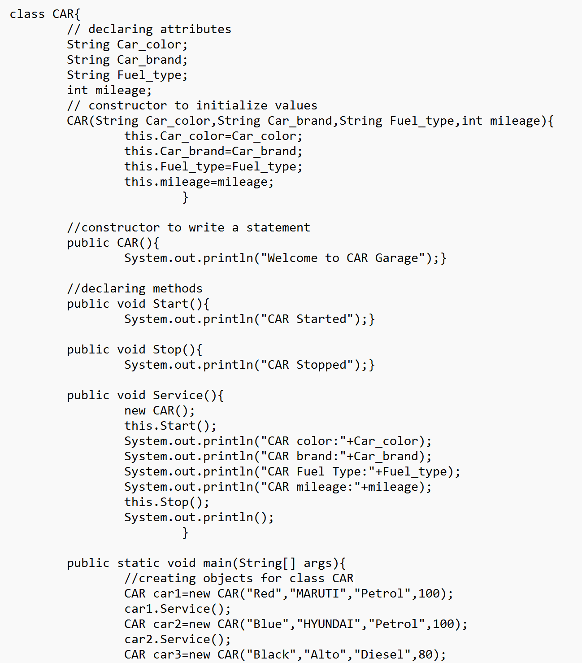



**OUTPUT**

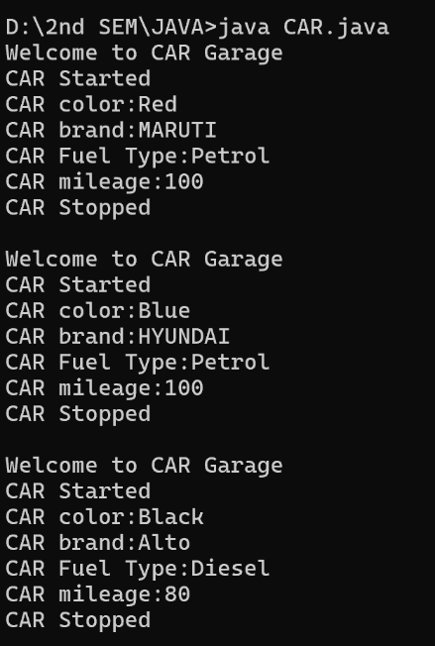

|  |  |  |
| --- | --- | --- |
| **S.No.** | **Errors** | **Rectification** |
| 1. | error: cannot find symbol  this.stop(); | Stop() |
| 2. | error: not a statement  this.mileage; | this.mileage=mileage; |

**Concepts to be known:**

* + System.out.println(" ")-to print the statement
  + String – to declare the data type as string
  + int – to declare the data types as integer
  + // - used to write comments

**Class Diagram**

|  |
| --- |
| CAR |
| Car_color: String  Car_brand: String  Fuel_type: String  mileage: int |
| + CAR()  + CAR(String, String, String, int)  + Start(): void  + Stop(): void  + Service(): void  + main(String[]): void |

**Program2)**

**AIM**-To create a class named bank account with two methods deposit() and withdraw():

1. In deposit()- whenever an amount is deposited, it has to be updated with the current amount.
2. Withdraw()- whenever an amount is being withdrawn it has to be less than the current balance otherwise print insufficient balance.

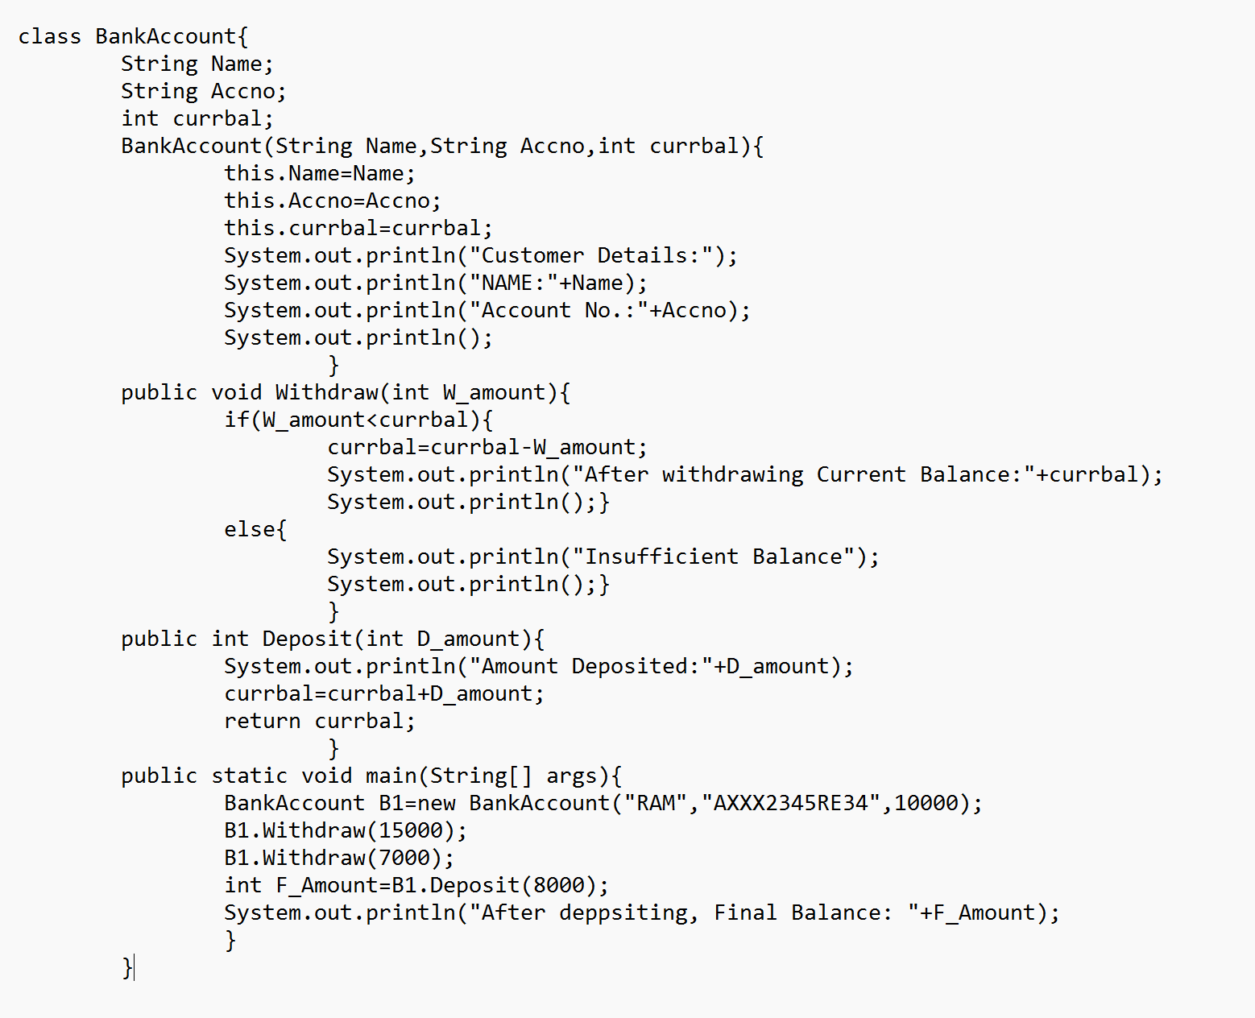

**OUTPUT**

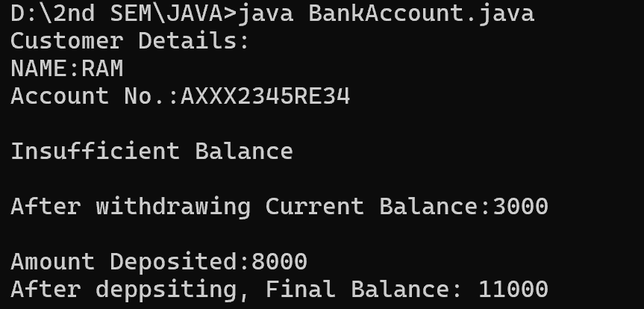

|  |  |  |
| --- | --- | --- |
| **S.No.** | **Errors** | **Rectification** |
| 1. | error: ';' expected  currbal=currbal-W_amount | Adding ; at the end |
| 2. | error: cannot find symbol  thiscurrbal=currbal; | this.currbal =currbal; |

**Concepts to be known:**

* + System.out.println(" ")-to print the statement
  + String – to declare the data type as string
  + int – to declare the data types as integer
  + // - used to write comments
  + this-

**Class Diagram**

|  |
| --- |
| BankAccount |
| Name: String  Accno: String  currbal: int |
| + BankAccount(String, String, int)  + Withdraw(int): void  + Deposit(int): int  + main(String[]): void |

**WEEK-4**

**Program1)**

**AIM-** To write a JAVA Program with class named Book:

1. The class should contain various attributes such as “title_of_book, Author, year_of_publication”.
2. It should also contain a constructor with parameters which initializes “title_of_book, Author, year_of_publication”.
3. Create a method which displays the details of the book “title_of_book, Author, year_of_publication”.
4. Display the details of the two books by creating two objects.

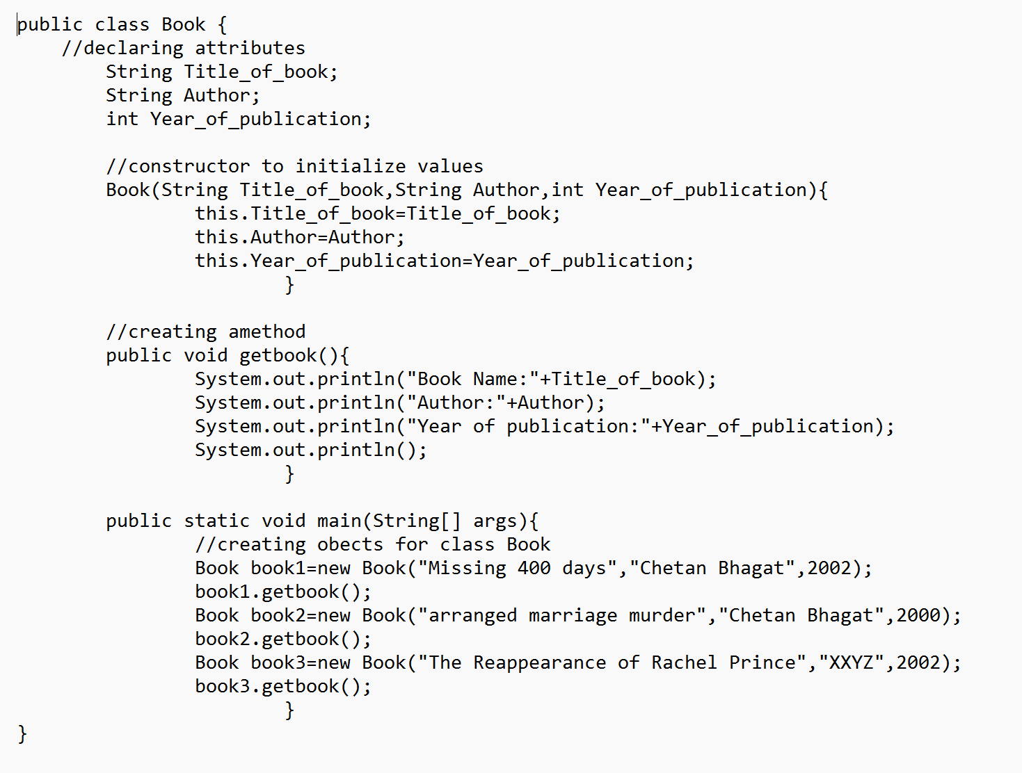

**OUTPUT**

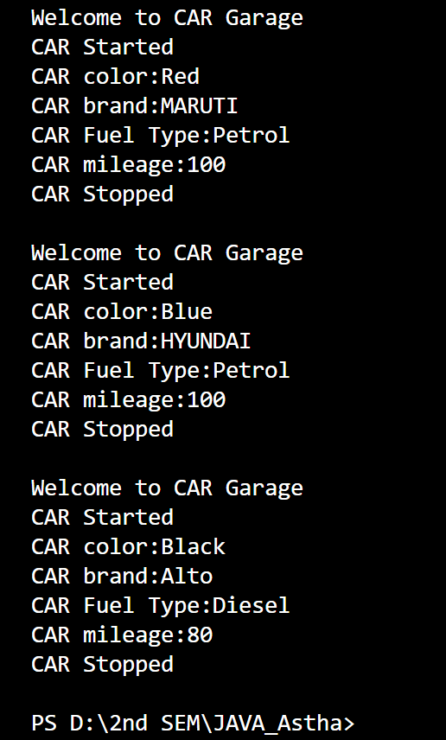

|  |  |  |
| --- | --- | --- |
| **S.No.** | **Errors** | **Rectification** |
| 1. | error: ';' expected  currbal=currbal-W_amount | Adding ; at the end |
| 2. | error: cannot find symbol  thiscurrbal=currbal; | this.currbal =currbal; |

**Concepts to be known:**

* + System.out.println(" ")-to print the statement
  + String – to declare the data type as string
  + int – to declare the data types as integer
  + // - used to write comments
  + this-

**Class Diagram**

|  |
| --- |
| Book |
| Title_of_book: String  Author: String  Year_of_publication: int |
| + Book(String, String, int)  + getbook(): void  + main(String[]): void |

**Program2)**

**AIM-** To create a JAVA program with class named Myclass:

1. with “static variable-count” of int type, initialize to zero and a constant variable “pi-double” to initialize to 3.1415 as attributes of that class.
2. Now define a constructor for Myclass that increments the count variable each time object for Myclass is created. Finally print values of “count” and “pi” variables.

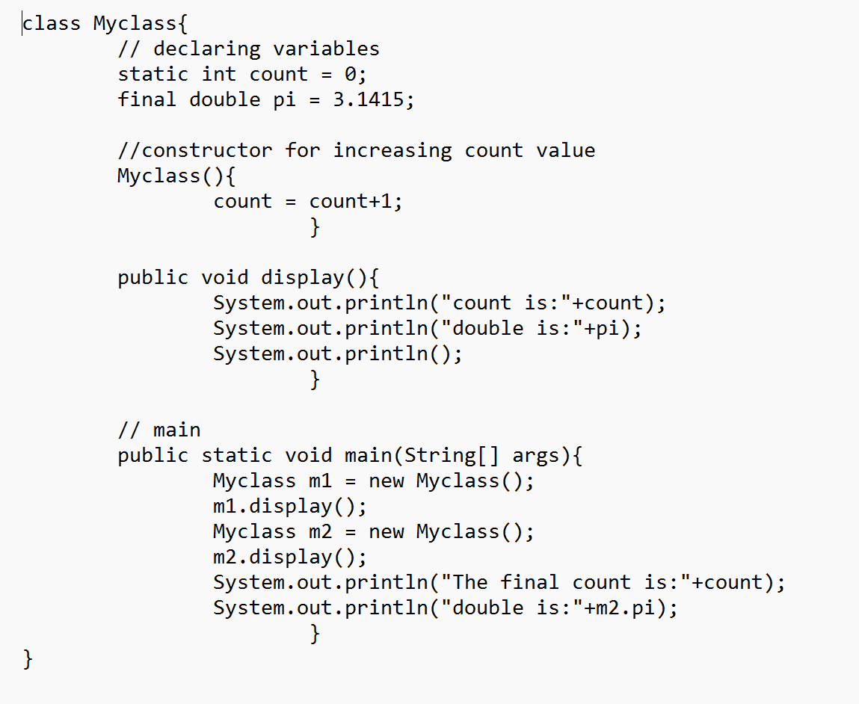

**OUTPUT**

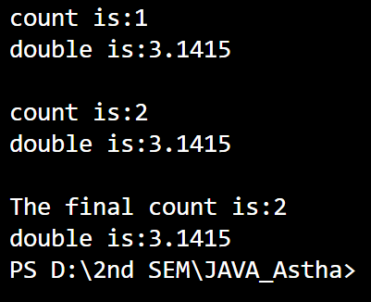

|  |  |  |
| --- | --- | --- |
| **S.No.** | **Errors** | **Rectification** |
| 1. | error: ';' expected  currbal=currbal-W_amount | Adding ; at the end |
| 2. | error: cannot find symbol  thiscurrbal=currbal; | this.currbal =currbal; |

**Concepts to be known:**

* + System.out.println(" ")-to print the statement
  + String – to declare the data type as string
  + int – to declare the data types as integer
  + // - used to write comments
  + this-

**Class Diagram**

|  |
| --- |
| Myclass |
| count: static int  pi: final double |
| + Myclass()  + display(): void  + main(String[]): void |